**SHRIMATI INDIRA GANDHI COLLEGE**

**TRICHY**

**DEPARTMENT OF MATHEMATICS**

**NAAN MUDHALVAN PROJECT REPORT**

**PROJECT PARTNER: SMART INTERNZ CLASS: III B.SC (MATHEMATICS)**

**PROJECT BY: DATA LITERACY WITH TABLEAU TEAM ID: NM2023TMID04508**

**ESTIMATION OF BUSINESS EXPENSES**

**INTRODUCTION**

OVERVIEW:

From operational costs to overheads, every penny spent plays a role in the financial symphony of a company. Accurate estimation is the compass guiding fiscal decisions, ensuring stability and growth. It involves forecasting expenditures with a keen eye on variables, acknowledging the dynamic nature of markets. A well-crafted estimation strategy is the bedrock of financial planning, fostering adaptability and resilience. Join me as we delve into the realm where numbers shape the destiny of businesses, navigating the intricate path of expenditures.

PURPOSE:

Financial Planning: Estimating expenses is essential for creating a structured financial plan, allowing businesses to set financial goals and allocate resources effectively.

Cost Control: By estimating and monitoring expenses, businesses can identify areas where costs can be reduced or optimized, improving overall financial efficiency.

**PROBLEM DEFINITION AND DESIGN THINKING**

EMPATHY MAP:

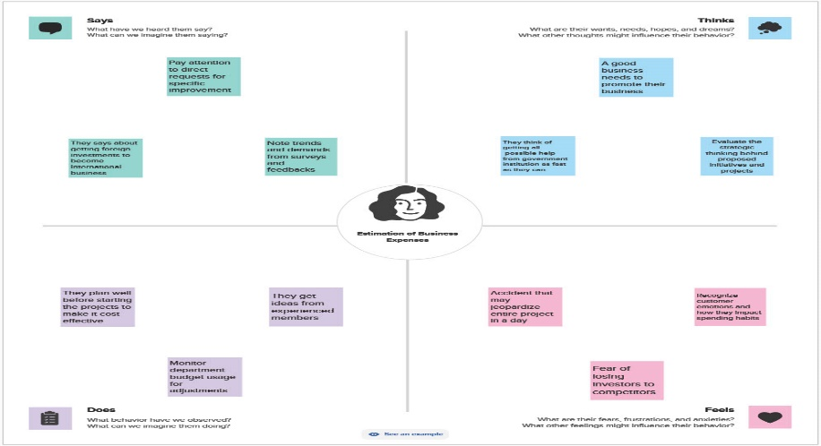

BRAINSTROMING MAP:

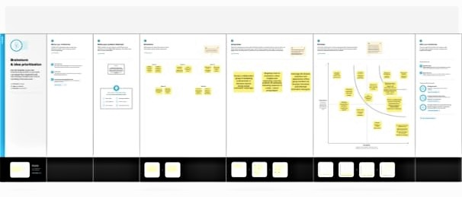

**RESULT**

**STORY 1**

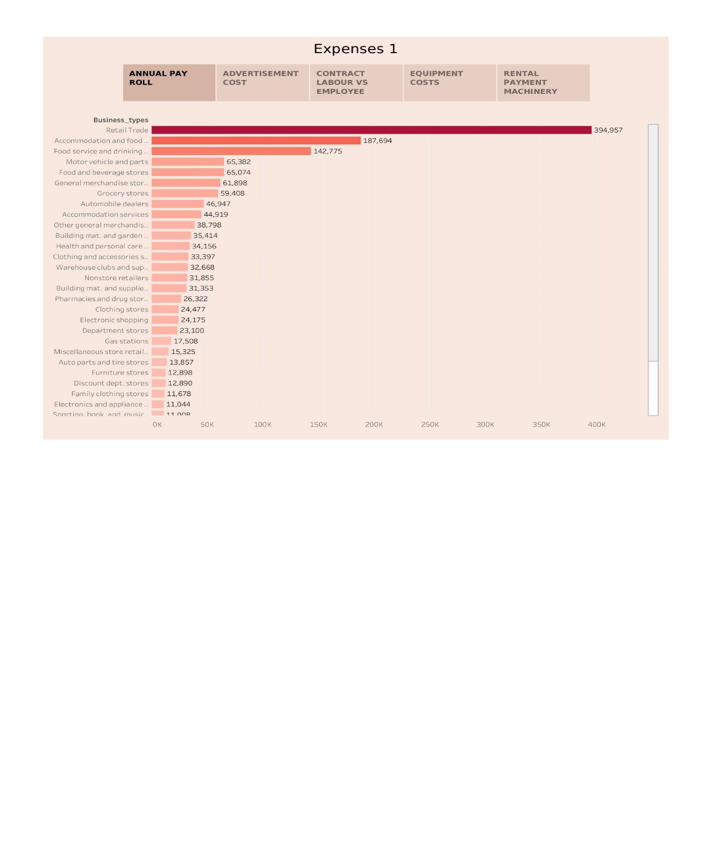

In this project, we conclude that the Annual pay roll, Advertisement cost, Contract labour vs employee, Equipment costs and Rental payment machinery.

**ADVANTAGES**

* Financial Control: Estimating expenses helps you gain better control over your finances. You can track where your money is going and make informed decisions to optimize spending.
* Budget Planning: It enables you to create a budget that aligns with your business goals. A well-planned budget ensures you allocate resources where they are needed most.
* Cost Reduction: By identifying unnecessary or excessive expenses, you can find opportunities to cut costs, improving profitability.
* Preparedness: Accurate expense estimates help you be prepared for unexpected financial challenges or emergencies, reducing the impact on your business.
* Investment Decisions: It assists in making informed decisions about investments, expansion, or scaling, as you have a clear understanding of your financial capabilities

**DISADVANTAGES**

* Inaccuracy: Estimations may not always reflect the actual expenses, leading to financial surprises and potential budget shortfalls.
* Time-Consuming: Creating and maintaining expense estimates can be time-intensive, diverting resources from other critical business activities.
* Complexity: Estimating expenses can be complex, especially in industries with variable or unpredictable costs, making it challenging to create precise forecasts.
* Opportunity Costs: Focusing too much on cost control might lead to missed opportunities for business growth or innovation.
* Overlooked Expenses: It's possible to underestimate or overlook certain expenses, leading to underbudgeting and financial strain.

**CONCLUSION**

Effective expense estimation is the cornerstone of sound financial management for any business. Accurate estimates provide financial control, aiding in budget planning and cost reduction.

While estimating expenses has its challenges, the benefits far outweigh the disadvantages.

Regularly review and adjust your estimates to ensure financial stability and preparedness.

Striking a balance between cost control and strategic investments is key to sustainable growth

**FUTURE SCOPE**

"Future scope" typically refers to the potential opportunities and growth prospects in a particular field, industry, or profession. To provide a more specific answer, please specify the field or industry you're interested in.

**APPENDIX**

SOURCE CODE:

https://public.tableau.com/app/profile/jayasree.s1725/vizzes